A Buffer Flushing Problem in CGI Code
Presented by Philip Ching
December 2, 2020

Summary:
I am running two systems using the same CGI code. I ran into a buffering problem (I think). I hope someone on DCPM can help me resolving this problem.
System A runs on CentOS 7 Linux with Perl V5.16
System B runs on Ubuntu Linux 18.04.4 with Perl V5.26.1
The following are 5 screenshots from System A, and 4 screenshots from System B to describe the symptoms.
Thank you.
Philip Ching

System A - Screenshot 1
User enters the keywords for Patent Search in the Main window.
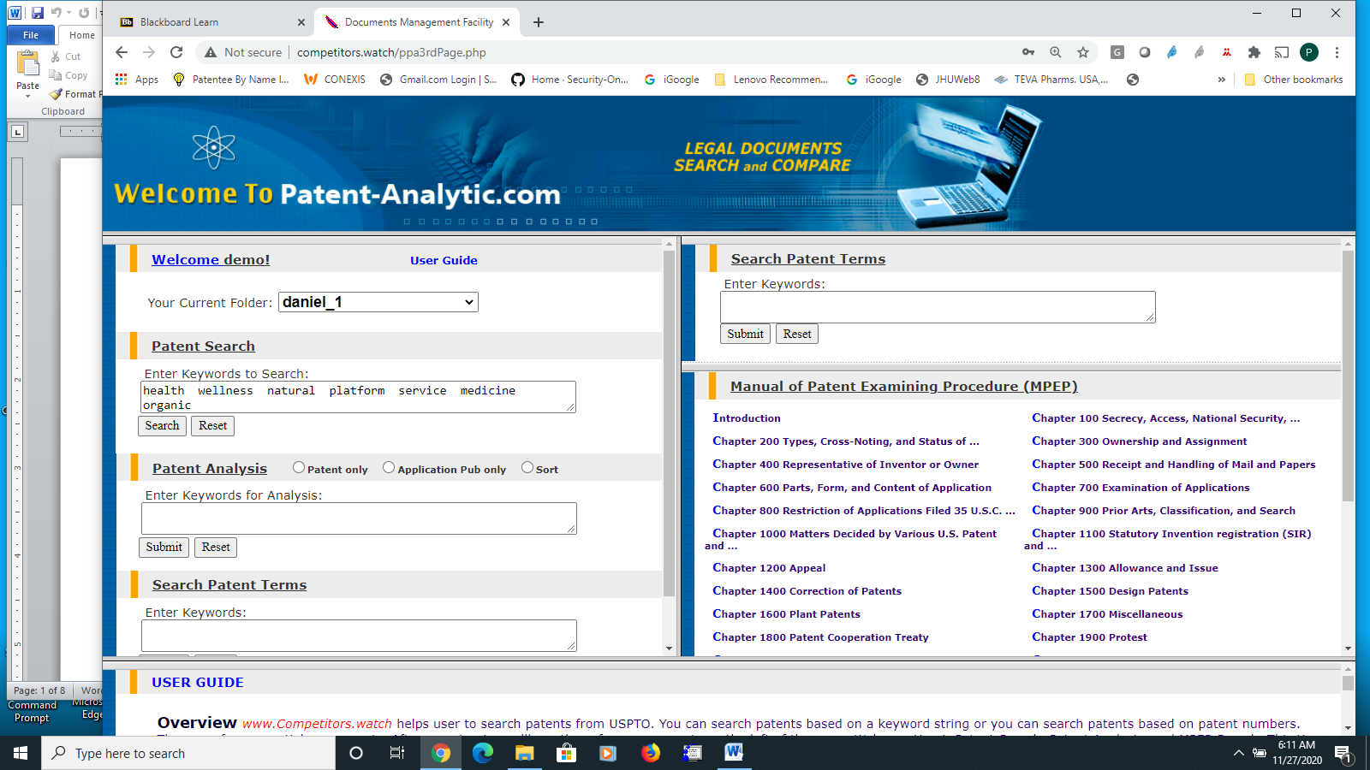

System A - Screenshot 2
The system follows with displaying “user search data” while the search is going on
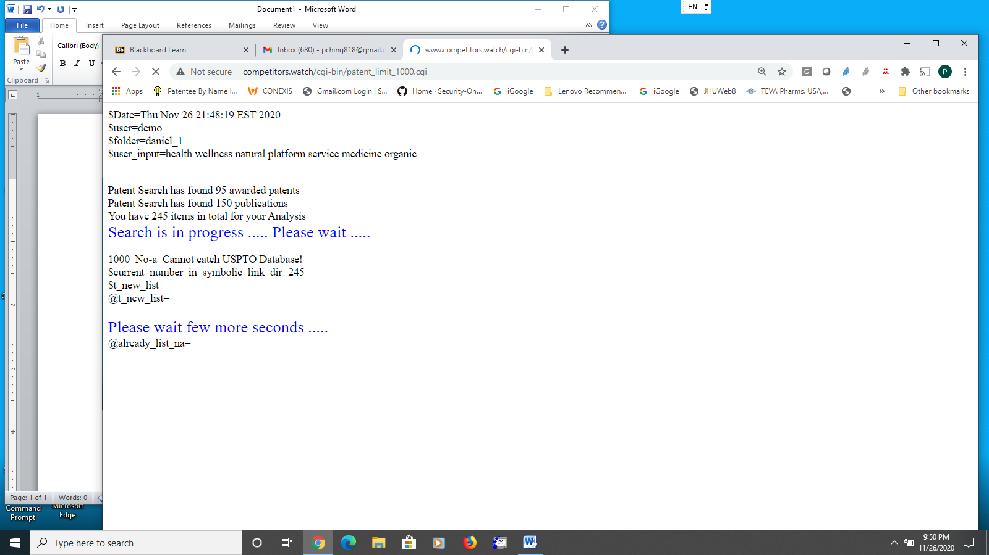

System A - Screenshot 3
When the system completes the downloading of the searched patents, it pops up a confirmation window for user to click and continue
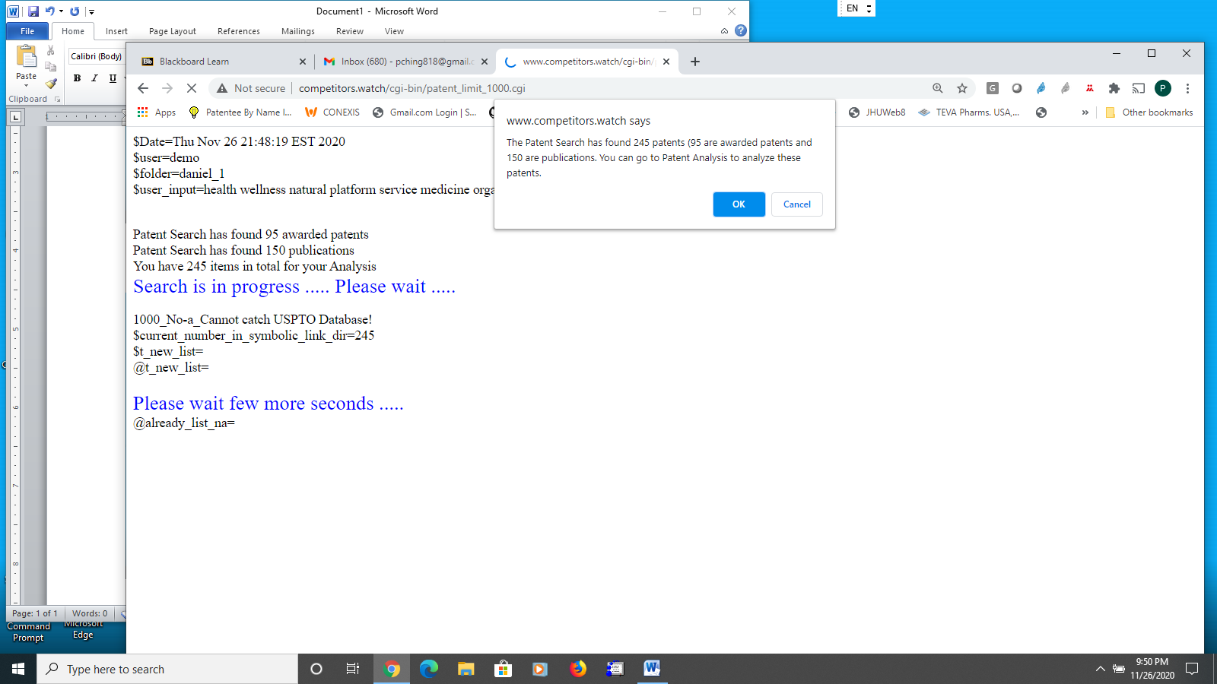

System A - Screenshot 4
After user clicks OK, the system displays the Main window which allows the user to proceed and do Patent Analysis
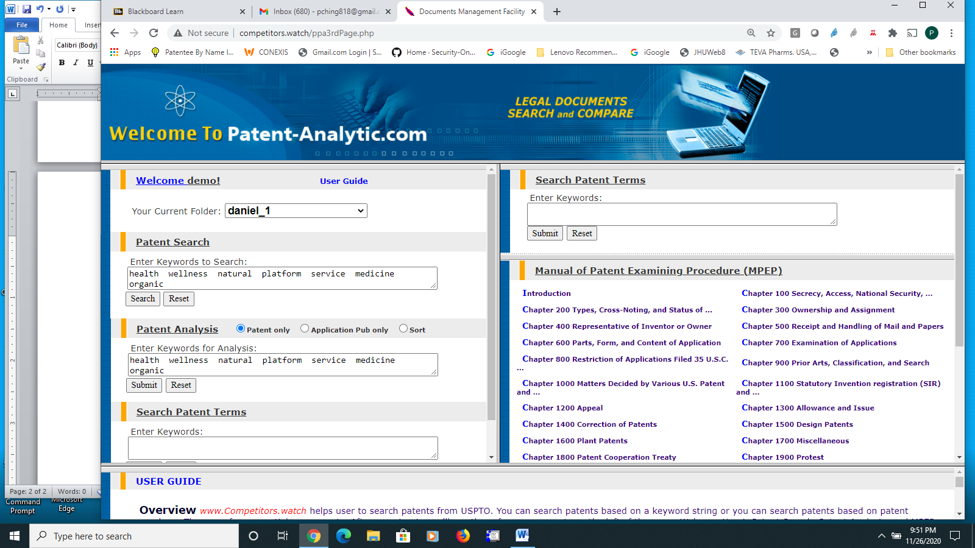

System A - Screenshot 5
The system displays the list of searched patents which is the start of Patent Analysis
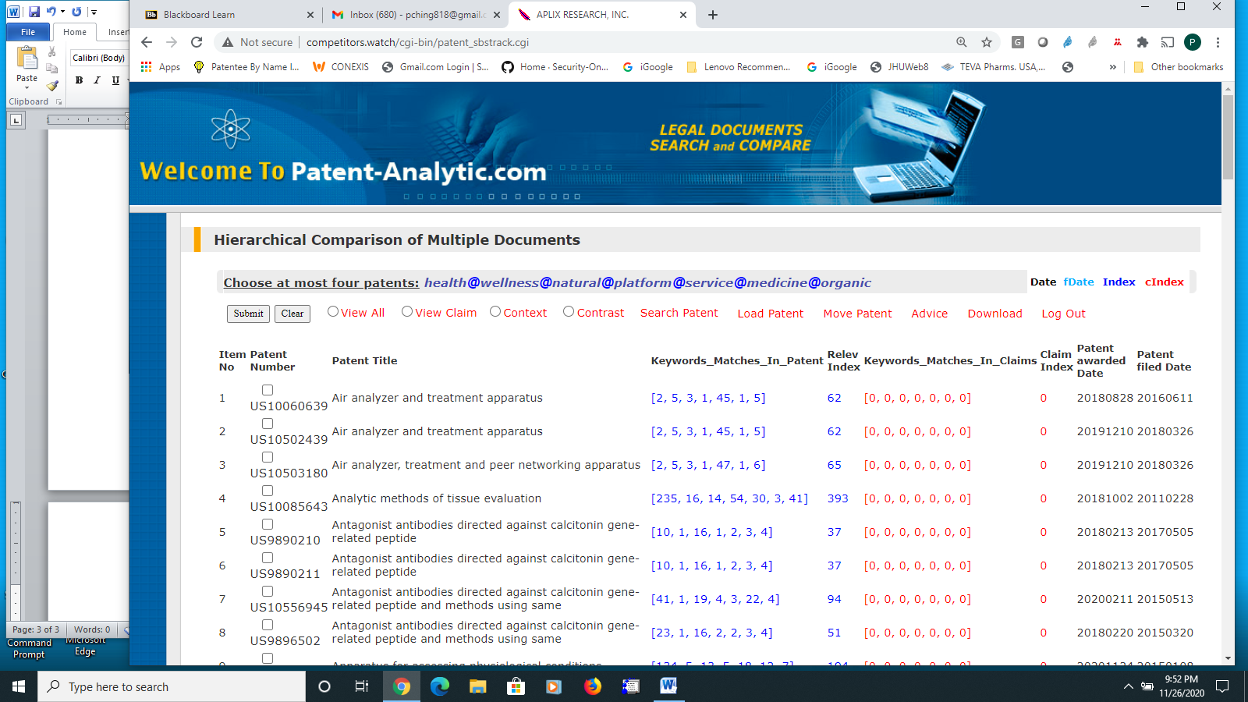

System B - Screenshot 1
This is the same action as in System A – Screenshot 1. User is put to wait in the Main window while the search is going on
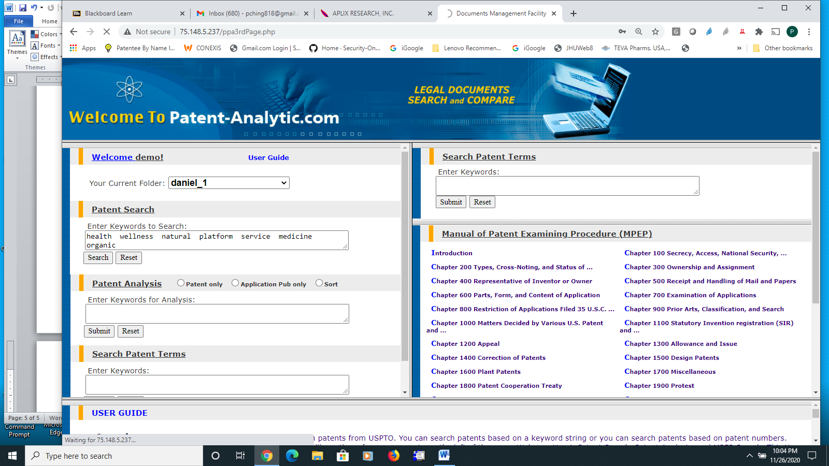

System B - Screenshot 2
When the system completes the downloading of the searched patents, it pops up a confirmation window for user to click and continue
Note: in this case user did not get the chance to view his “user search data”. This indicates the system did not flush out the “user search data” in time
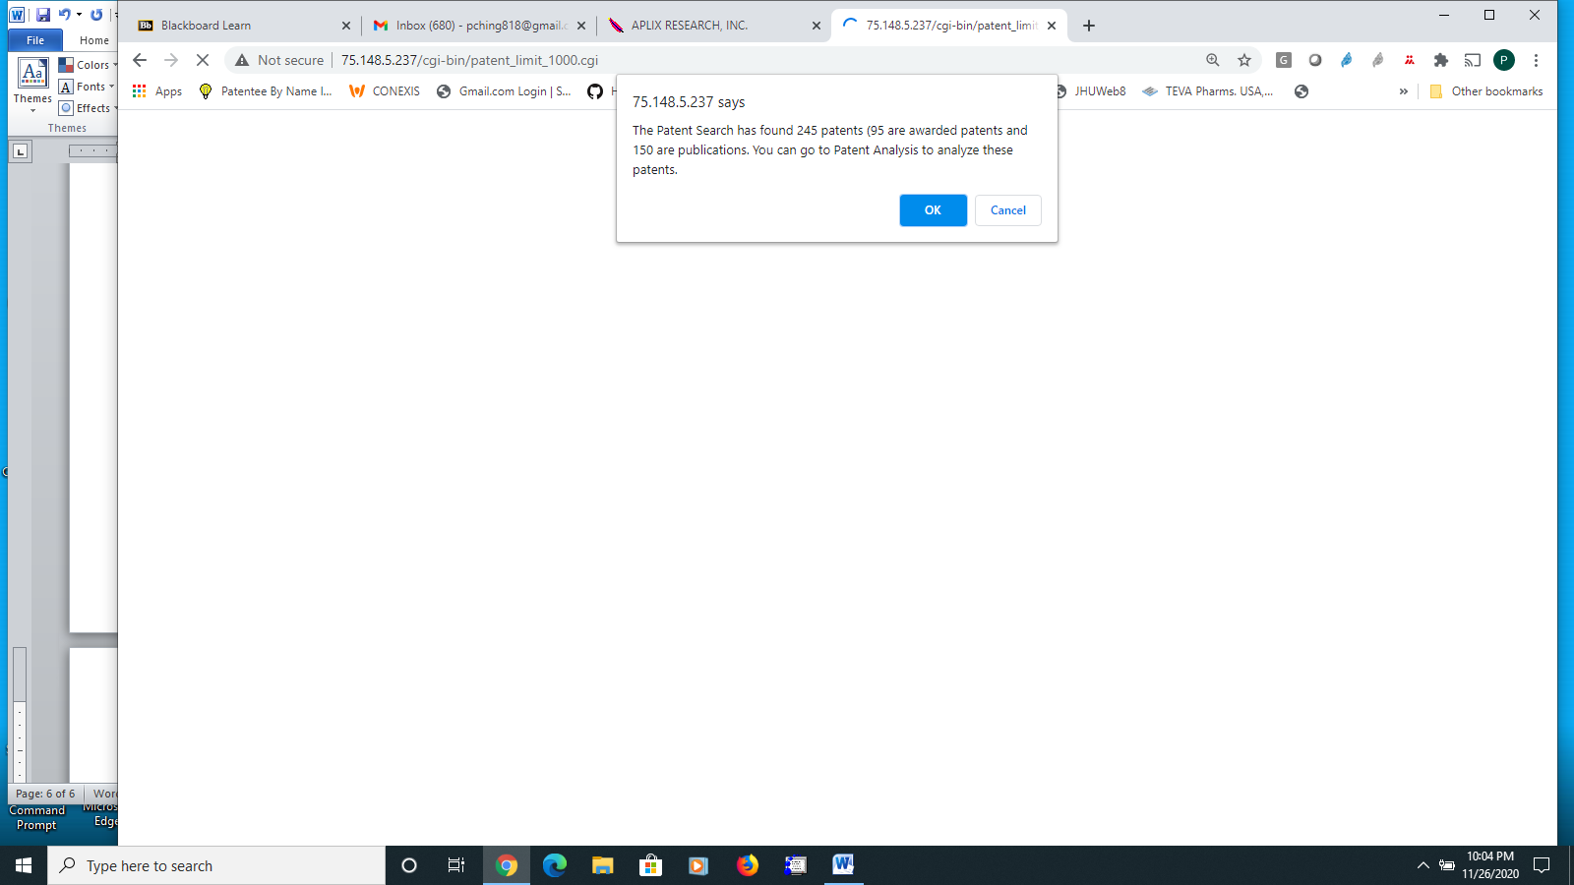

System B - Screenshot 3
Note: this is the same behavior as in System A – Screenshot 4
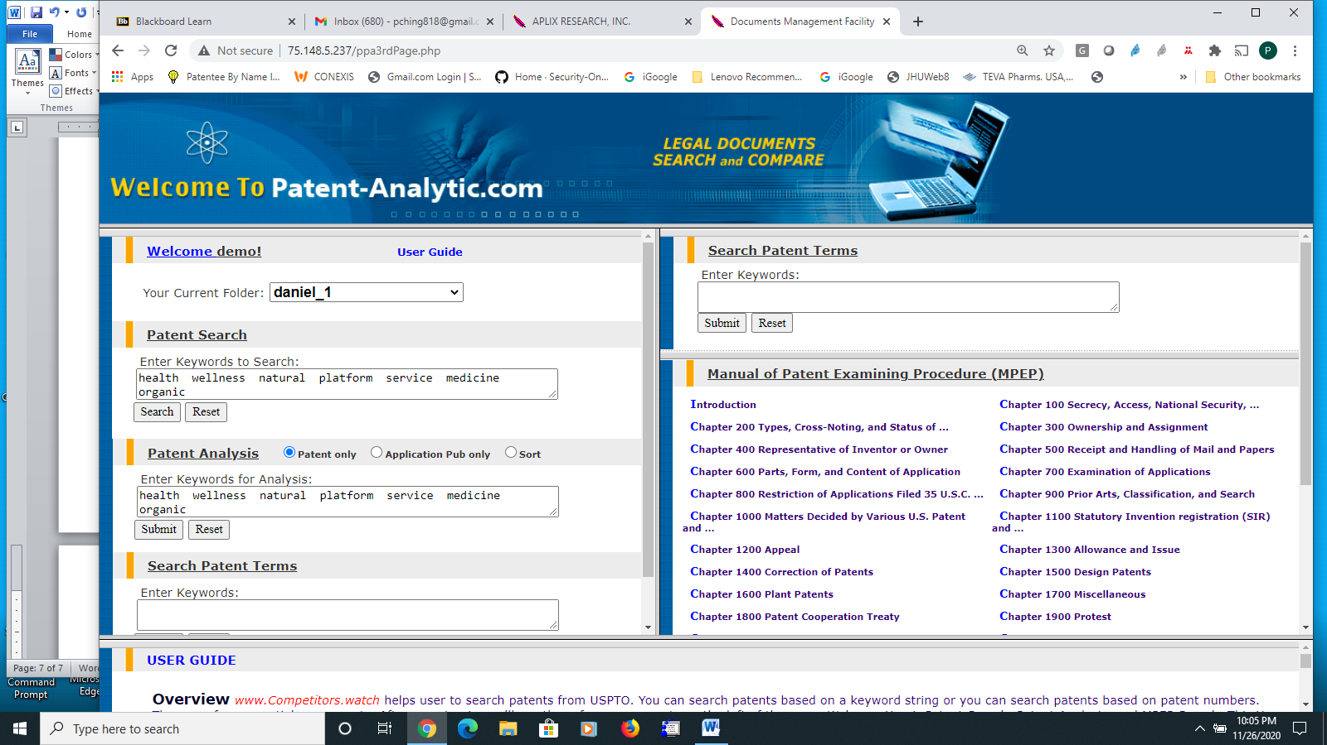

System B - Screenshot 4
Note: this is the same behavior as in System A – Screenshot 5
